Project for Digital Communications

Student: Yan Fei
Tutor: Dr. David Siddle

I declare that this assignment is my own work, that sources of reference are acknowledged and that it has not been submitted for any other course. I understand that plagiarism is a serious offence under the University’s regulations and that appropriate penalties will be applied if I am found to have submitted plagiarism work.
Contents
Introduction of the Ambulance Radio System 1
Requirements 1
Background of Designing a Digital System 1
Channel Encoding and Decoding 3
BCH Code 3
Interleaving 3
Modulation and Demodulation 4
Binary Frequency-Shift Keying (BFSK) 4
Phase-Shift Keying (PSK) 4
M-ary Modulation 4
Discussion For Using These Modulation 5
Maximum Doppler Shift 5
Channel Capacity 5
The Symbol Error Probability 5
The Type of Modulation 6
Coding the Image and Voice 7
JPEG 2000 7
G.729: multi-purpose ITU-T standard for increased bandwidth availability and short delay 7
Multi-user digital modulation technique 8
Supplement of the Ambulance System 9
References 10

Introduction of the Ambulance Radio System

Requirements
In this exercise, we are going to design a digital system for the ambulance service. There are following conditions we should consider:
- This is a UHF radio system;
- The speed limit of the vehicles is 120km/h;
- There are three types of data we want to transfer:
  - Data from a patient monitoring system
  - Pictures taken with a digital camera
  - Digitized ‘telephone quality’ voice
- The radio system will operate on a frequency of around 2GHz;
- The bandwidth is 10kHz;
- The signal to noise ratio should exceed 50dB for about 20% of the time;
- The patient monitoring system produces data at a fixed rate of 100 bits per second;
- We should encode both voice and picture messages.

Background of Designing a Digital System
In order to transmit the signal between transmitter and receiver, we cannot transmit the original signal directly because the original signal may not be suitable for the transmission. It means that the signal will be interrupted and cause errors due to the fading and noise. Thus, we have two methods to cope with these problems:
- Modulation and Demodulation
- Channel Encoding and Decoding
The modulation process is used to convert the original signal into the analog signal which is better to be transmitted over the propagation channels. Demodulation is used to remove the modulation from an analog signal to get the original baseband signal back.
The encoding and decoding procedures are used to reduce and correct the errors for the transmission of the signal.
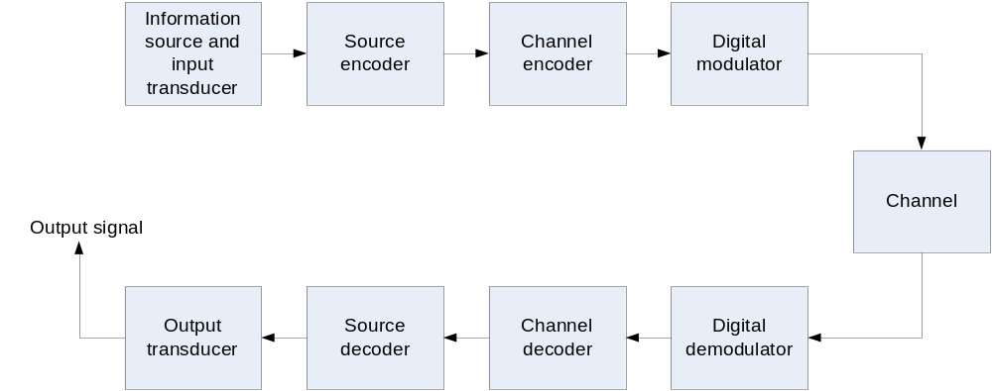
This is the basic elements for the digital communications system. In this system design, we just consider the channel encoder, channel decoder, digital modulator and digital demodulator. The source encoder and decoder are used to digitize the incoming analogue waveform and analogize the digital signal separately (A/D converters), which we do not concern about these. Of course, in the channel, we should consider the noise and fading.
Thus, the system design should be as following:

Channel Encoding and Decoding

BCH Code
We are concerned with the coding system. The coding system will add some extra bits in the encoder and remove them in the decoder. The decoder detects errors, corrects errors, or a combination of both. If we have a good coding system, the information on the input and output will be identical.
Because this is the ambulance system which is for the emergency uses such as saving people’s lives. The transmitting data should be as precise as possible for monitoring the patient’s condition. Thus, we need a code system with very good ability of detecting and correcting errors.
Hamming code is the famous code for error detection process. However, it just can detect two errors and corrects one error in one symbol. That is not enough for this system.
There is a random error correcting code here called the BCH code. This code handles randomly located errors in a data stream according to its inherent limitations. If the code word used is long enough, the BCH code can detect and correct any number of errors.
K | N | Code rate R=k/n | No. of bits corrected
4 | 7 | 0.57 | 1
5 | 15 | 0.33 | 3
24 | 63 | 0.38 | 7
64 | 127 | 0.5 | 10
247 | 255 | 0.97 | 1
171 | 255 | 0.67 | 11
11 | 1023 | 0.01 | 255
Example of BCH Code
Through the table above, we can see that if we use BCH (171, 255), the BCH code can correct 11 errors. So if we use BCH to encode the digital signal, we will get the more reliable transmission after the transmission of the signal. Although there will be more data which should be transmitted, I think the reliability is more important than the amount of data due to the ambulance system which is used to deal with emergency for saving people.

Interleaving
This block is used to make the errors distribute more evenly. For instances, if we used BCH (171,255), then we use matrix interleaver and deinterleaver. So this is the 15×15 interleaving. The encoded data will be read into the matrix interleaver by row and read out by columns, this will scatter the distribution of errors. Later, we use the matrix deinterleaver to reconstituting the original signal. This interleaving process will decrease the density of the errors, which could increase the correcting ratio of the decoding process. Of course interleaving will cost some time for filling with the matrix, but it is useful for reduce the errors and makes the system more reliable.

Modulation and Demodulation
There are many types of modulation and demodulation we can use in this system. The key point is to find out which one is most suitable. Also, for individual modulation and demodulation, we should give them parameters to make them fit for the system.
Amplitude-Shift Keying (ASK)
- One binary digit represented by presence of carrier, at constant amplitude;
- Other binary digit represented by absence of carrier.
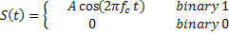

The ASK modulation is susceptible to sudden gain changes, which is an inefficient modulation technique.

Binary Frequency-Shift Keying (BFSK)
Two binary digits represented by two different frequencies near the carrier frequency.
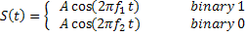
The BFSK is less susceptible to error than ASK, but it will occupy more bandwidth.

Phase-Shift Keying (PSK)
For Differential PSK (DPSK), phase shift is with reference to previous bit.
- Binary 0 – signal burst of same phase as previous signal burst;
- Binary 1 – signal burst of opposite phase to previous signal burst.

M-ary Modulation
The advantage of M-ary signaling is that a higher information transfer rate is possible for a given symbol rate and corresponding channel bandwidth, the disadvantage is that M-ary baseband signalling results in reduced noise/interference immunity when compared with binary signalling as it becomes more and more difficult to distinguish between symbol states.

Discussion For Using These Modulation

Maximum Doppler Shift
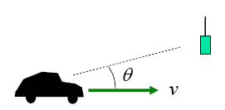
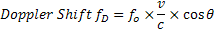
So Maximum Doppler Shift should be:
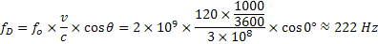

Channel Capacity
The Shannon-Hartley capacity limit for error-free communication is given by:

The Symbol Error Probability
Through the following formula, we can get the symbol error probability for M-ary bipolar baseband signaling:
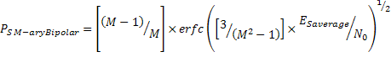
For different number of symbol states with other same parameters, we can get the graph below:
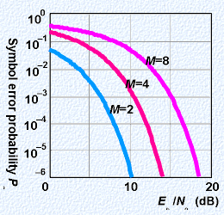
We can see the more symbol states may cause more symbol errors, so our system, we should use M=2, which means binary modulation.

The Type of Modulation
Firstly, we should not consider using MFSK, because this modulation will occupy too many bandwidths. From the theory of the FSK, we can see that it uses different frequencies to modulate the signal. In order to deal with the Doppler Shift, the difference between two frequencies should be at least the maximum Doppler Shift, which is equal to 222Hz. It means that we will waste a lot of bandwidth if we using FSK. Even more, we also have more than one ambulance in our system and there types of data should be transmitted, so we need to use the bandwidth effectively. That is the reason why I do not use FSK in our system.
BPSK is the simplest form of PSK. It uses two phases which are separated by 180°. This modulation is the most robust of all the PSKs since it takes serious distortion to make the demodulator reach an incorrect decision. It is, however, only able to modulate at 1 bit/symbol and so is unsuitable for high data-rate applications when bandwidth is limited. In our system, for certain situation, we need to transmit a lot of data (voice, image and monitoring data) in a very short time. So it is also not suitable for this ambulance system.
So we decide to use ASK modulation in this system. Although the ASK modulation does not have very good fault tolerant capacity. We have already used the BCH code and Interleaver in our system, which are the efficient ways to cope with the errors. Thus, I think the ASK is the most suitable modulation in ambulance system.

Coding the Image and Voice
In order to use the bandwidth effectively, we should also encode the image and voice in the source coding process.

JPEG 2000
JPEG 2000 is a new image coding system that uses state-of-the-art compression techniques based on wavelet technology. Its architecture should lend itself to a wide range of uses from portable digital cameras through to advanced pre-press, medical imaging and other key sectors. The aim of JPEG 2000 is not only improved compression performance over JPEG but also adding (or improving) features such as scalability and editability.
JPEG 2000 gains up to about 20% compression performance for medium compression rates in comparison to the first JPEG standard. For lower or higher compression rates, the improvement can be somewhat greater Good applications for JPEG 2000 are large images, images with low-contrast edges — e.g., medical images. It has, however, notably higher computational and memory demands.
Because the JPEG2000 is used widely in the medical environment, we should use this coding system to process the original image before transmitted.

G.729: multi-purpose ITU-T standard for increased bandwidth availability and short delay
In November 1995, the G.729 standard, also referred to as CS-ACELP® (Note 1), was adopted by the International Telecommunication Union, a United Nations organization. Like the G.728 standard, the G.729 algorithm speech codec is based on the renowned Code Excited Linear Prediction (CELP) model. Similar in quality to 32 Kbps ADPCM, G.729 offers toll-quality speech at only 8 Kbps, creating opportunities for significant increases in bandwidth utilization to existing telephony and wireless applications. Operating on 10 ms frames, this multi-purpose standard also allows moderate transmission delays.
As a proven standard, G.729 is being widely adopted in many new VoIP applications. The benefits of toll-quality speech at 8 Kbps, with moderate delay and processing requirements, make G.729 popular in applications like Internet Telephony, web collaboration tools, and visual telephony, where quality, delay, and bandwidth are keys.
So we can use G.729 for encoding the voice in the source coding process of our system.

Multi-user digital modulation technique
There are three types of the multi-user digital modulation techniques:
- Frequency division multiple access (FDMA)
- Time division multiple access (TDMA)
- Code division multiple access (CDMA)
Because the FDMA will affect the efficiency of the transmission bandwidth, the bandwidth is limited as 10 KHz, which is not enough for the FDMA; we should not use the FDMA.
The CDMA requires a large amount of bandwidth to be available in a contiguous block in order to ensure that sufficient spreading can be obtained to mitigate the frequency selective fading and to ensure that there is sufficient coding gain in the system. The bandwidth we have is just 10 KHz which is very small, so the CDMA is also not suitable for our system.
TDMA is the reasonable solution for this system because the user has access to a modem operating at a rate several times that required to support his own data throughput. It means the user can send the information in a time slot that is shorter than the own message transaction. The users of the system can share the same channel for using the different time slot. The other advantage of the TDMA is that the user cannot be given a fixed repeated time slot, but a time slot “on demand”, it likes the handshaking protocol for requesting the transmission and accepting the request. The users can be given variable date rate services by simply assigning them multiple time slots.
Thus, we choose the TDMA as our multi-user digital modulation.

Supplement of the Ambulance System
The channel capacity is 332190b/s; the monitoring data rate is 100b/s, the voice data rate is 8000b/s and the image data rate we want to use is 4000b/s.
So this system, we can have the following maximum number of the ambulance working simultaneously.
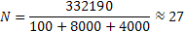
Because we should maintain the SNR exceeds 50dB during the 20% of the time. We should consider that the capability of this system should be 6 ambulances in case of the SNR is lower than 50dB in the 80% of the time. The data rate can be increased when SNR exceeds 50dB in order to transmit the data faster.

References
W. Stallings, Wireless Communications and Networks, Prentice Hall, 2nd Edition, 2005.
Bateman, A. Digital Communications. Design For The Real World. Addison-Wesley, 1999.
http://en.wikipedia.org/wiki/Frequency-shift_keying
http://en.wikipedia.org/wiki/Phase-shift_keying
http://en.wikipedia.org/wiki/Amplitude-shift_keying
http://en.wikipedia.org/wiki/Multiple_frequency-shift_keying
http://en.wikipedia.org/wiki/JPEG_2000
http://www.jpeg.org/jpeg2000/
http://www.voiceage.com/
http://www.sipro.com/g729onestop.php
http://www.itu.int/ITU-T/index.html
http://en.wikipedia.org/wiki/Code_division_multiple_access

